Core Components of Custom Bank Integrations
# Source: AI Source: Provided by: [Data Path: Persons Table -> ID Column: 1, Name_En Column: Motasem Essam] -> From: [ChatGPT] on [1/21/2026]
Great follow-up! If you're organizing a folder or building documentation around Custom Bank Integrations, it's helpful to clearly outline the main components that make up the system.

✅ Core Components of Custom Bank Integrations
# Source: AI Source: Provided by: [Data Path: Persons Table -> ID Column: 1, Name_En Column: Motasem Essam] -> From: [ChatGPT] on [1/21/2026]
These are the typical building blocks you'd implement or manage:

1. 🧾 Checkout Flow
# Source: AI Source: Provided by: [Data Path: Persons Table -> ID Column: 1, Name_En Column: Motasem Essam] -> From: [ChatGPT] on [1/21/2026]
- UI/UX for collecting payment information from users
- Input fields (card number, CVV, expiration)
- Error validation and card formatting
- Optional: saved cards, installment options, localization

2. 🔐 Security & PCI Compliance
# Source: AI Source: Provided by: [Data Path: Persons Table -> ID Column: 1, Name_En Column: Motasem Essam] -> From: [ChatGPT] on [1/21/2026]
- PCI DSS compliance (Payment Card Industry Data Security Standard)
- HTTPS, TLS encryption
- Tokenization of card data
- 3D Secure authentication (e.g., OTP verification)
- Secure storage (if any) — often avoid storing card data yourself

3. ⚙️ Transaction Logic
# Source: AI Source: Provided by: [Data Path: Persons Table -> ID Column: 1, Name_En Column: Motasem Essam] -> From: [ChatGPT] on [1/21/2026]
- Initiating a payment request
- Handling success, failure, or pending status
- Order ID generation
- Verifying transaction signatures or hashes (to prevent tampering)
- Logging and auditing transaction data

4. 🔌 Bank API Integration
# Source: AI Source: Provided by: [Data Path: Persons Table -> ID Column: 1, Name_En Column: Motasem Essam] -> From: [ChatGPT] on [1/21/2026]
- Authentication (API keys, OAuth, HMAC, etc.)
- Calling bank endpoints:
  - Create payment request
  - Get transaction status
  - Refunds or reversals
- Parsing API responses (success/failure/error)
- Managing API timeouts and retries

5. 📬 Webhook Handling (Optional but Important)
# Source: AI Source: Provided by: [Data Path: Persons Table -> ID Column: 1, Name_En Column: Motasem Essam] -> From: [ChatGPT] on [1/21/2026]
- Receive callbacks from the bank to confirm payment status
- Validate signatures (bank → your server)
- Update internal order or transaction status accordingly

6. 📤 Settlement & Reconciliation
# Source: AI Source: Provided by: [Data Path: Persons Table -> ID Column: 1, Name_En Column: Motasem Essam] -> From: [ChatGPT] on [1/21/2026]
- Track incoming payments from the bank
- Match payments with orders
- Reconcile reports against your database
- Generate financial reports or summaries

🗂️ Folder Structure Example
# Source: AI Source: Provided by: [Data Path: Persons Table -> ID Column: 1, Name_En Column: Motasem Essam] -> From: [ChatGPT] on [1/21/2026]
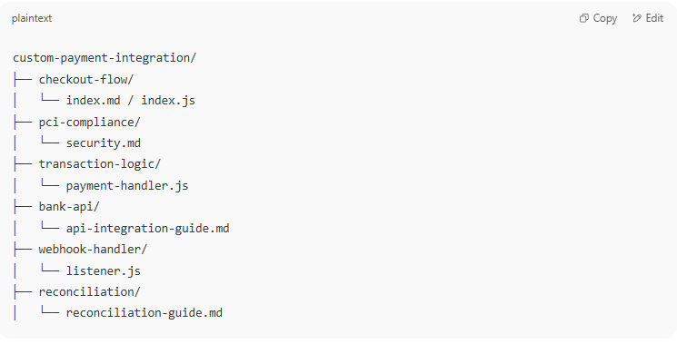

custom-payment-integration/
├── checkout-flow/
│ └── index.md / index.js
├── pci-compliance/
│ └── security.md
├── transaction-logic/
│ └── payment-handler.js
├── bank-api/
│ └── api-integration-guide.md
├── webhook-handler/
│ └── listener.js
├── reconciliation/
│ └── reconciliation-guide.md

